Intake Sheet, page 1, Shaded Area
John | 1: Yes | 2: No | 3: Yes | 4: Yes | 5: Yes
George | 1: No | 2: No | 3: Yes | 4: Yes | 5: Yes

Filing Status = Head of Household
AGI -$28,734
Federal Refund - $7,056
State Refund – $

Personal Information
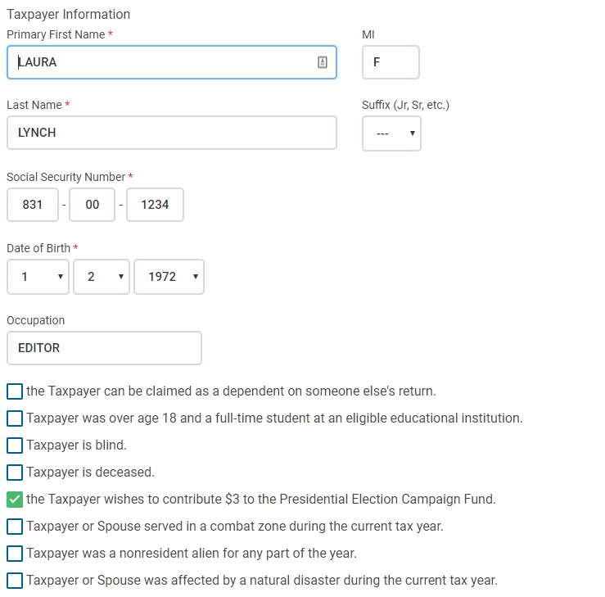

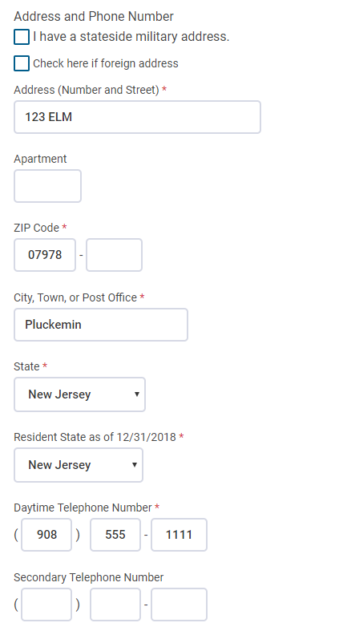
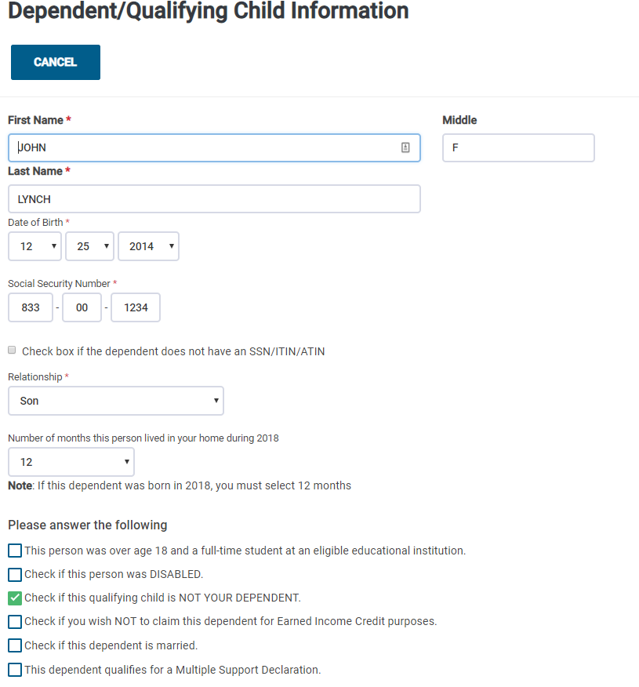
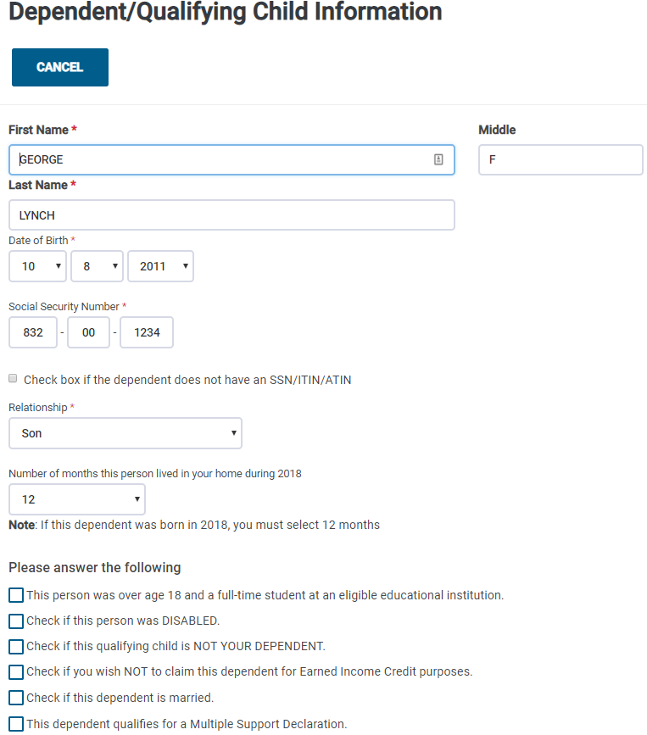

W-2 Wages
ACME Corp
EIN – includes a number
Check employer name and address
ACME CORP
123 MAIN
PLUCKEMIN
NJ
Box 1 = 14,598
Box 2 = 1,002
Box 3 = 14,598
Box 4 = 905
Box 5 = 14,598
Box 6 = 212
Box 12
Code = DD
Amount = 3,000
Box 14
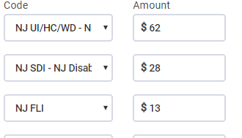

New Jersey Information
State = New Jersey
EIN = a number is in the box
Box 16 = 14,598
Box 17 = 575

ACME Diner
EIN – includes a number
Check employer name and address
ACME DINER
123 MAIN
PLUCKEMIN
NJ
Box 1 = 2,532
Box 2 = 328
Box 3 = 1,944
Box 4 = 157
Box 5 = 2,532
Box 6 = 37
Box 7 = 588
Box 8 = 250
Note: The amount from box 8 automatically goes to Form 4137. You can do a search for the 4137 in
TSO, or view the completed form in the printed return.

Box 14
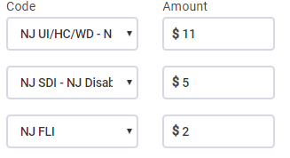

New Jersey Information
State = New Jersey
EIN = a number is in the box
Box 16 = 2,532
Box 17 = 201

Form 4137
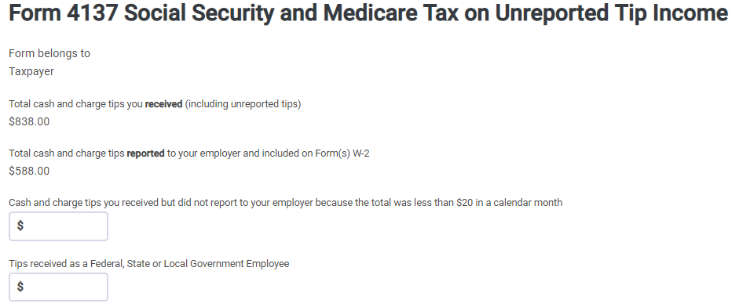

1099-R

ACME IRAS
EIN – includes a number
Check PAYER’S name and address
ACME IRAS
123 MAIN
PLUCKEMIN
NJ
Box 1 = 5,000
Box 2a = 5,000
Box 4 = 750
Box 7 = 1
IRA/SEP/SIMPLE box checked

Form 5329 should have been completed because Laura is disabled.
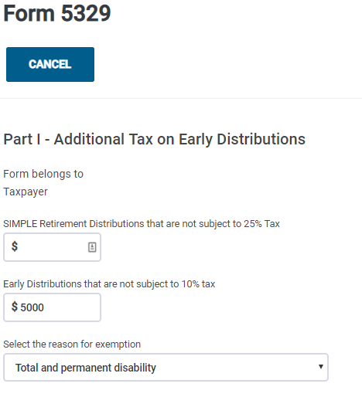

1099-R

ACME Pensions
EIN – includes a number
Check payer’s name and address
ACME PENSIONS
123 MAIN
PLUCKEMIN
NJ
Box 1 = 5,400
Box 2a = 5,400
Box 7 = 3

Check that box on 1099-R checked to move amount to 1040 Line 7

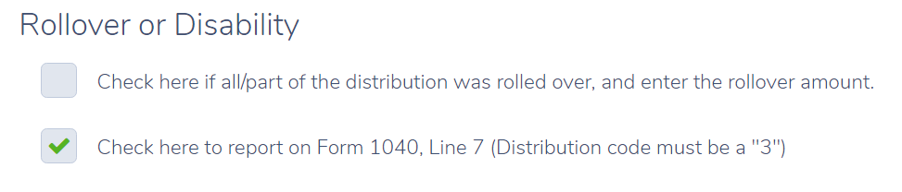

NJ Checklist
Amount of the ACME Pensions Disability Pension should be entered on the NJ Checklist in the Income Subject to Tax Section. (Adjustments to line 20a)

1099-MIsc

ACME Services
EIN – Check a number is entered
Payer
ACME SERVICES
123 MAIN
PLUCKEMIN, NJ
Box 7 = 5,000

ACME Partners
EIN – Check a number is entered
Payer
ACME PARTNERS
123 MAIN
PLUCKEMIN, NJ
Box 7 = 7,000

Schedule C

Basic Information
Business Name = Laura Lynch
Business Code = 561410
Description of Business = Document preparation
All other lines blank

Questions About Business
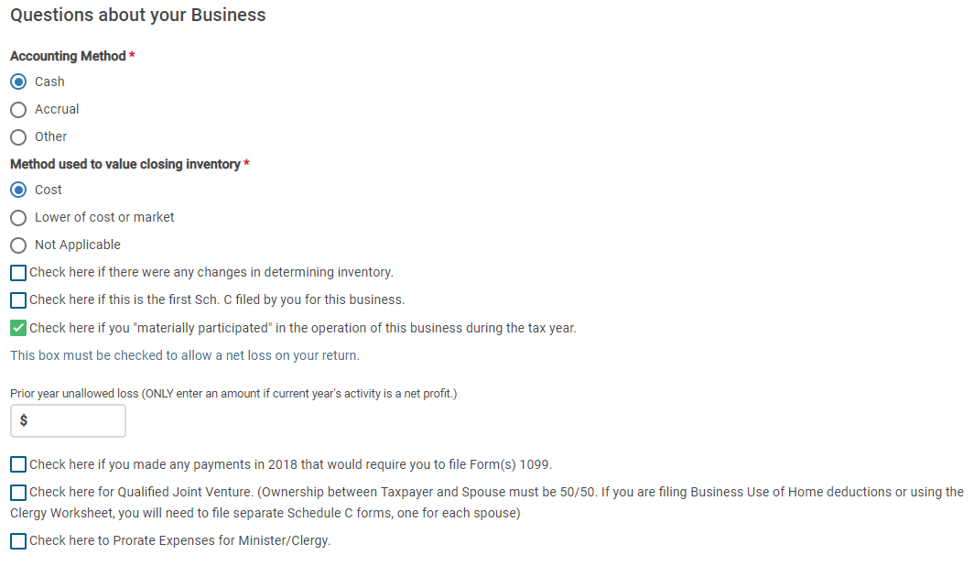

Income
Total amounts from both 1099 MISCs.
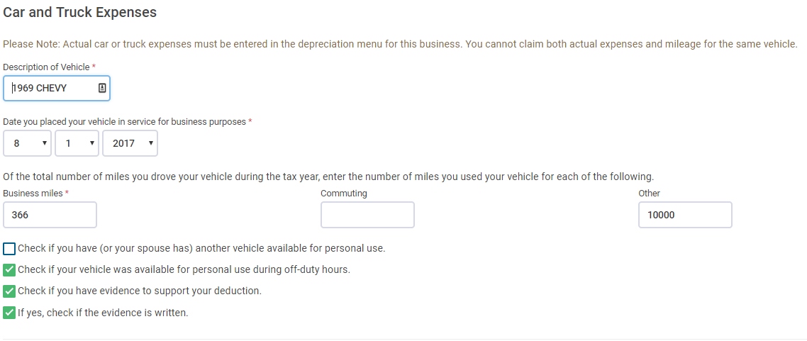
Other Expenses
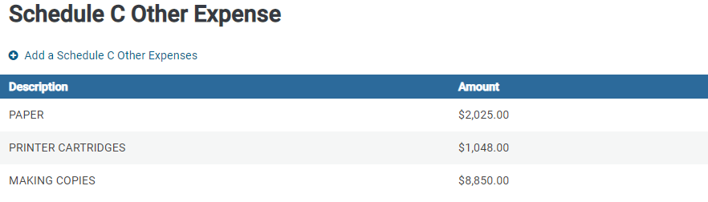

Alimony Received
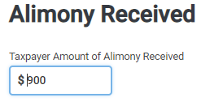

Schedule A Medical
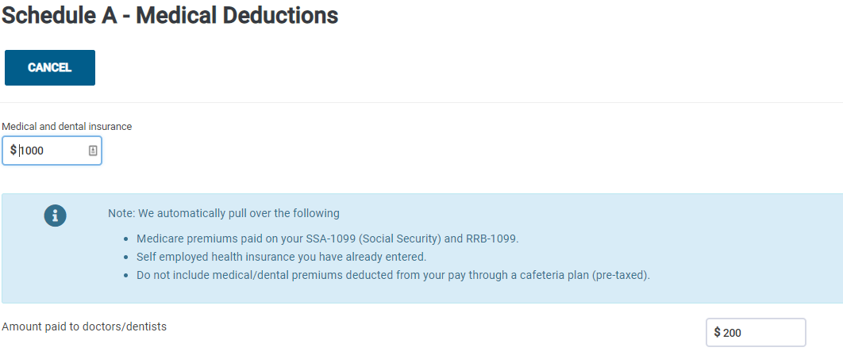

Child Care Credit Form 2441

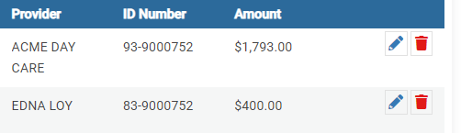

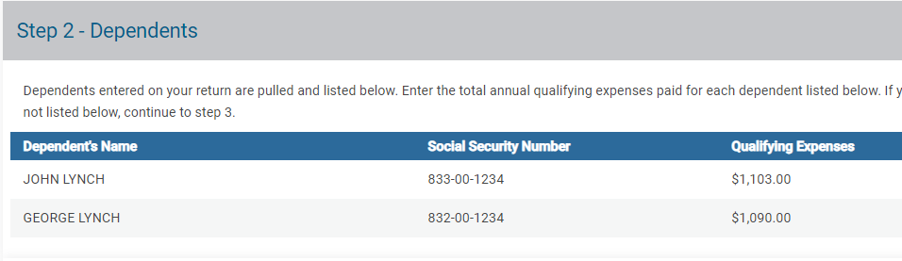

Health Insurance
Everyone on the return has Health Insurance for the entire year.
Screen 1=Yes
Screen 2 = No
Screen 3 = OK
Screen 4 = Yes

Efile
The Efile screens have not been updated in TSO 2018. Check that the Federal File Type has been entered.

STOP UNTIL NJ IS AVAILABLE IN TAXSLAYER.

New Jersey Return

Check that the numbers shown in the NJ Checklist below have been properly entered in to TaxSlayer.

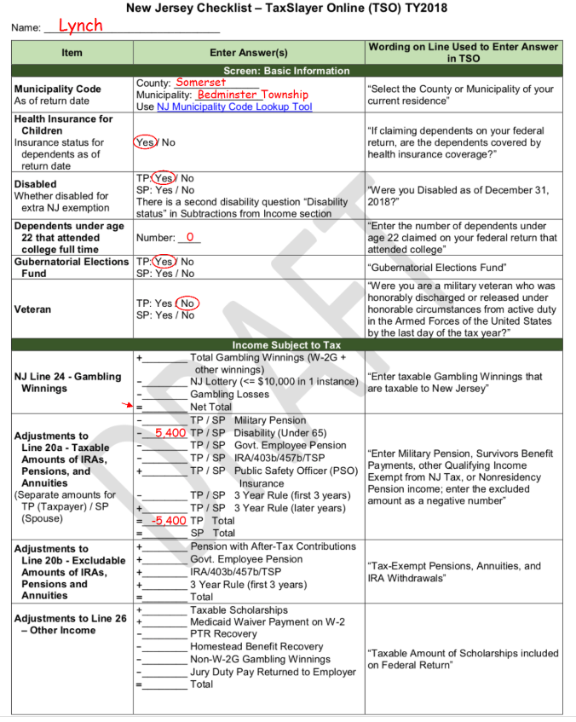

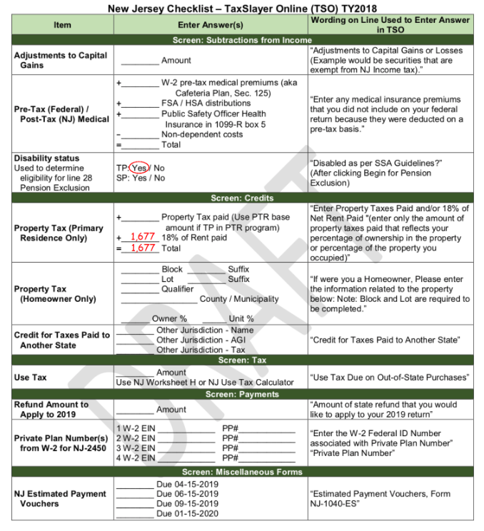

Rent Calculation: [(755*6) + (798*6)] * .18 = 1677

